GITHUB SIGNUP STEPS

1. **Go to**[**https://github.com/join**](https://github.com/join)**in a web browser.** You can use any web browser on your computer, phone, or tablet to join. 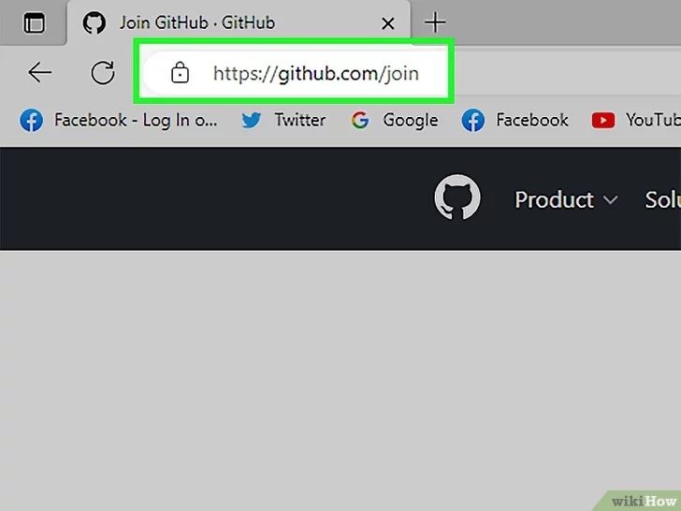
2. **Enter your personal details.**

In addition to creating a username and entering an email address, you'll also have to create a password. Your password must be at least 15 characters in length *or* at least 8 characters with at least one number and lowercase letter.

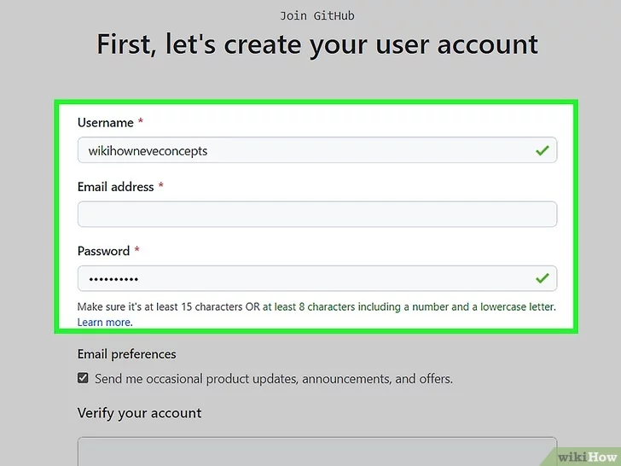

1. **Click Verify to start the verification puzzle.** The instructions vary by puzzle, so just follow the on-screen instructions to confirm that you are a human. A green checkmark will appear after completing the puzzle.

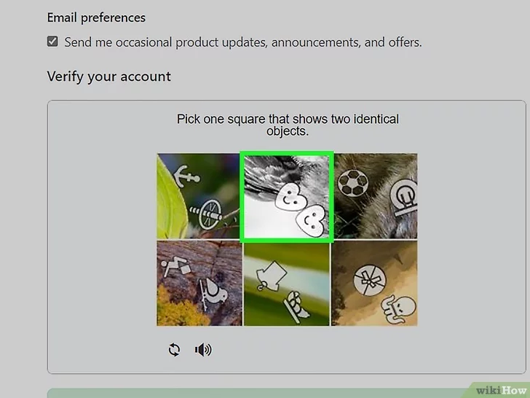

1. **Click the green Create account button.** It's below the form, at the bottom of the page. This will take you to an email verification page.

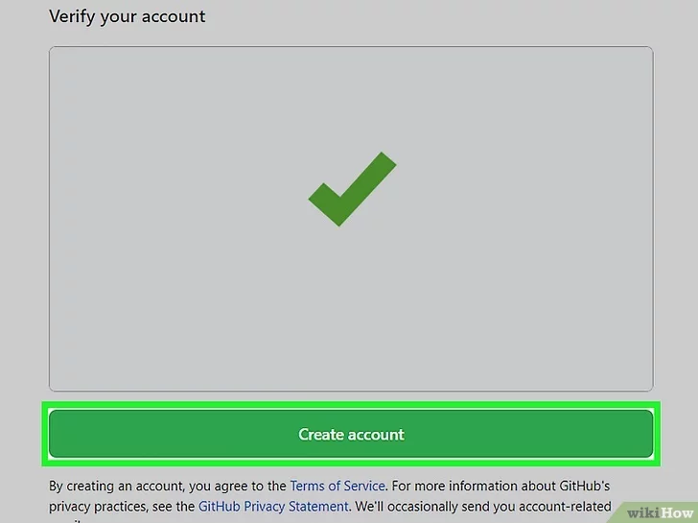

**Verify your email by entering the code.** After clicking **Create account**, you’ll receive an email with a code. Enter this code on the verification page. Entering the code will automatically take you to the welcome page.

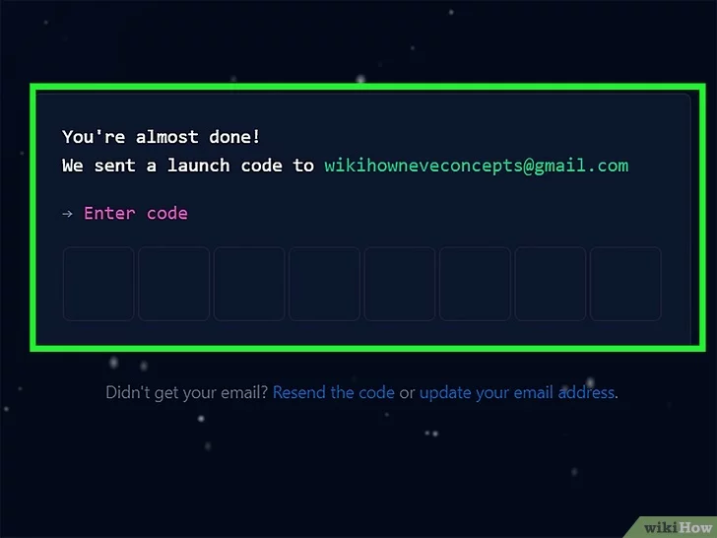

1. **Select your preferences and click Continue.** GitHub displays a quick survey that can help you tailor your experience to match what you're looking for. You’ll be sent to the plan selection page after completing the survey.

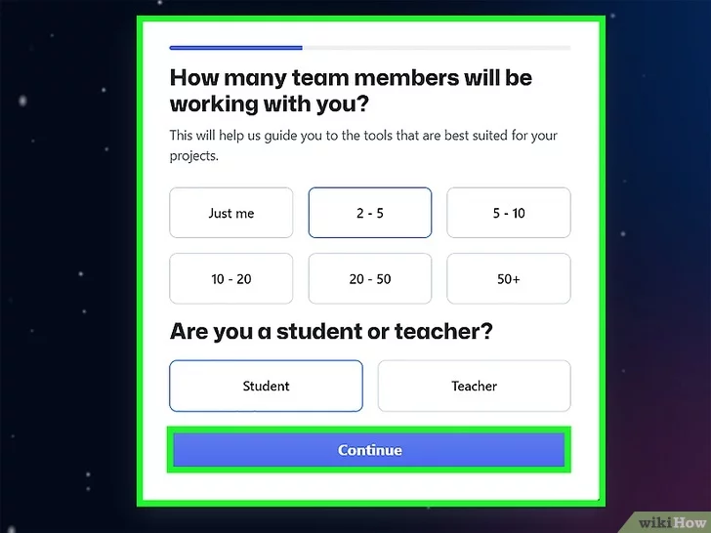

1. **Note the types of plans offered by GitHub.** There are a few different plans to choose from, varying in the amount of features provided , CLICK ON CONTINUE FOR FREE.



1. Create repository

